PHYSICAL EDUCATION

STUDIES – 2A/B

Semester 1 Examination Paper

##### Question/Answer Booklet

Student Name: _________________________________

Teachers Name: _________________________________

### Structure of this paper

|  |  |  |  |
| --- | --- | --- | --- |
| **Section** | **No. of questions available** | **No. of questions to be attempted** | **Marks Available** |
| **A** | **20** | **20** | **/20** |
| **B** | **14** | **14** | **/100** |
| **C** | **1** | **1** | **/15** |
|  |  | **Total** | **/135** |

### Instructions to candidates

1. Write your answers in the spaces provided in this Question/Answer Booklet. A blue or black ballpoint or ink pen should be used. Wherever appropriate, fully labelled diagrams, tables and examples should be used to illustrate and support your answers.
2. Section A is to be answered on the separate multiple answer sheet supplied.

**Section A – Multiple Choice**

A multiple choice answer sheet is provided for you to answer questions in this section. For each question, place a cross (X) over the correct answer.

This section has **TWENTY (20)** questions. Attempt **ALL** questions.

Allow approximately 30 mins for this section [20 marks].

___________________________________________________________________

**1.** Which of the following is not a function of the human skeleton?

A. Produce red blood cells.

B. Act as a store house for calcium.

C. Enable movement

D. Ensures the individual maintains correct posture.

**2.** Which of the following correctly shows the chemical breakdown of ATP to produce energy, when the athlete is using the aerobic energy system?

1. ADP + PC →ATP
2. ATP →ADP + Pi + energy
3. ATP → energy + CO2 + H2O
4. ATP + lactic acid → energy

**3.** The rate of ATP production and the amount of ATP produced by each of the three energy systems is different. Which of the following is true for the ATP-CP system?

1. fast rate, high yield
2. slow rate, low yield
3. fast rate, low yield
4. slow rate, high yield

**4.** Which two of the following physiological characteristics need to increase in order to increase cardiac output?

1. Increased ventilation rate and heart rate
2. Increased haemoglobin concentration in the blood and increased muscle glycogen
3. Increased stroke volume and heart rate
4. Increased phosphocreatine stores and increased blood pressure

**5.** Ventilation rate increases in response to exercise. What is the physiological reason for this?

1. Increased blood pressure
2. Increased heart rate
3. Increased oxygen requirement
4. Increased cardiac output demands

**6.** The function of the pulmonary vein is to:

1. Send deoxygenated blood from the heart to the lungs
2. Send oxygenated blood from the heart to the body
3. Return deoxygenated blood from the body to the heart
4. Return oxygenated blood from the lungs back to the heart

**7.** An 18-year-old woman wants to gain cardiovascular health benefits from physical activity. Which one of the following activities should she undertake?

A. Social tennis every two weeks.

1. A 30-minute walk every day.
2. Twenty push-ups every morning.
3. Weight training when she feels like it.

**8.** Heart-rate is often used to measure and monitor performance. A heart-rate that becomes constant during submaximal exercise indicates

A. that sufficient oxygen is available to meet energy demands.

B. a high level of aerobic capacity.

C. that lactic acid is restricting muscle contraction.

D. that stores of glycogen in the muscles have been depleted.

**9.** Some important chronic effects of a long-term aerobic training program are

A. decreased resting heart-rate and decreased stroke volume during rest.

B. increased stroke volume and increased cardiac output during maximal exercise.

C. increased maximum heart-rate and increased resting heart-rate.

D. increased maximum oxygen uptake and decreased cardiac output during maximal

exercise.

**10.** Refer to the following table:

|  |  |  |  |  |
| --- | --- | --- | --- | --- |
| Week | Sets | Repetitions | Load (kg) | Rest (s) |
| 1 | 2 | 10 | 60 | 40 |
| 2 | 2 | 10 | 60 | 40 |
| 3 | 2 | 12 | 60 | 40 |
| 4 | 3 | 12 | 60 | 40 |

Which training principle is best illustrated in the table above?

A. Intensity.

B. Frequency.

C. Overload.

D. Specificity.

**11.** What is necessary for the immediate resynthesis of ATP during a long-jump event?

A. Glycogen

B. Lactic acid

C. Oxygen

D. Phosphocreatine

**12.** What type of muscular contraction occurs in the biceps as it shortens when a ‘curl’ is performed using a free weight?

A. Concentric

B. Eccentric

C. Isokinetic

D. Isometric

**13.** What are the likely physiological adaptations to resting heart rate, haemoglobin levels and resting blood pressure in response to aerobic training?

|  |  |  |  |
| --- | --- | --- | --- |
|  | **Resting Heart Rate** | **Haemoglobin levels** | **Resting blood pressure** |
| A. | Increased | Decreased | Increased |
| B. | Increased | Decreased | Decreased |
| C. | Decreased | Increased | Decreased |
| D. | Decreased | Decreased | Increased |

**14.** Refer to the following graph, which shows the stroke volume of two swimmers as the speed of swimming gradually increased:



As their speed increased, the swimmers’ stroke volume was different, but their cardiac output was the same. This was because swimmer Y had a

A. higher heart-rate than swimmer X.

B. lower heart-rate than swimmer X.

C. larger vital capacity than swimmer X.

D. smaller vital capacity than swimmer X.

**15.** Refer to the following table, which shows one section of a training program:

|  |  |  |  |
| --- | --- | --- | --- |
| Repetitions | Distance (m) | Intensity (%) | Recovery time (s) |
| 5× | 70 | 100 | 30 |
| 5× | 60 | 100 | 35 |
| 5× | 50 | 100 | 20 |

The section of a training program shown above is an example of a

A. fartlek program, best suited to a triathlete.

B. long-interval training program, best suited to a 400-metre runner.

C. short-interval training program, best suited to a soccer midfielder.

D. circuit training program, best suited to a basketballer.

**16.** The left atrium receives blood directly from the:

A. aorta

B. pulmonary arteries

C. pulmonary veins

D. superior and inferior vena cava

**17.** Which of the following does not occur during inspiration?

A. Diaphragm rises into the thoracic cavity.

B. The pressure in the lungs falls.

C. The intercostals contract.

D. The rib cage moves upward and outward.

**18.** Which of the following activities requires muscular strength only and would not be regarded as an activity involving muscular power?

A. Shot put.

B. Tug-of-war

C. Cricket fast bowling.

D. Boxing.

**19.** Below is a sample of a short-interval training program.

|  |  |  |  |  |
| --- | --- | --- | --- | --- |
| Sets | Repitions | Distance (m) | Time (sec) | Rest Interval (sec) |
| 3 | 12 | 20 | 2.2 | 10 |

In the table below, which of the following alternatives does not demonstrate the correct application of the progressive overload principle to the program shown above?

|  |  |  |  |  |  |
| --- | --- | --- | --- | --- | --- |
|  | Sets | Repitions | Distance (m) | Time (sec) | Rest Interval (sec) |
| A | 3 | 13 | 20 | 2.2 | 10 |
| B | 3 | 12 | 22 | 2.2 | 10 |
| C | 5 | 12 | 20 | 2.2 | 10 |
| D | 3 | 12 | 20 | 2.0 | 10 |

**20.** The fibrous connective tissue which attaches muscle to bone is called:

A. ligament.

B. muscle fibre.

C. tendon.

D. Cartlige

**END OF SECTION A**

**Section B – Short Answer**

This section has **TWELVE (12)** questions. Attempt **ALL** questions.

Allow approximately 75 minutes for this section [80 marks].

___________________________________________________________________________

**Question 1**

In the table below, name the fitness component required for the groups of activities listed.

|  |  |
| --- | --- |
| **Activities** | **Fitness component** |
| * a spike in volleyball * a leaping intercept in netball or basketball * a drive or long fairway shot in golf | ***Power***  ***Or Co-ordination*** |
| * 1500 m swim * completing a triathlon * running a marathon | ***Cardio-Respiratory/Aerobic Endurance***  ***Or Muscular endurance***  ***N.B Not Cardiovascular*** |
| * tug-of-war * attempting a static hold against an opponent in amateur wrestling * leaning out and attempting to keep a boat upright while sailing | ***Strength*** |
| * sprinting 100 m * AFL full forward leading into space * long jump run up | ***Speed*** |

**4 marks**

**Question 2**



**i.** Name the major fitness component being demonstrated in the photograph above.

***Flexibility (1 mark)***

**ii.** List and explain the impact of **one** of the factors affecting this fitness component.

***(1 mark for identifying factor and one mark for impact)***

***• Joint structure – the type of joint is the single biggest determinant of the amount of flexibility there is at each joint.***

***• Age – without considerable work, flexibility will continue to decline with age.***

***• Sex – females, on average, have better flexibility than males.***

***• Body/muscle temperature – an increase in muscle and ligament temperature has a significant positive impact on flexibility.***

***• Structure surrounding the joint – the more muscle tissue and/or adipose tissue there is around a joint, the less flexible it will be.***

**iii.** Which **two** muscle groups are responsible for the extension of the squash player’s left hip?

***1. Glueteals 3. Quadriceps***

***2. Hip Flexors***

**5 marks**

**Question 3**

Study the training program shown below.



**a.** Name **three** recognised training methods used in this program.

***Continuous, Circuit, Interval or resistance (1 mark Each)***

**3 marks**

**b.** Identify and explain **two** training principles that have been correctly applied in this program.

***Any 2 of the following - (1 mark for identifying factor and one mark for explanation)***

***Progressive Overload - for the body to continue to improve fitness levels (obtain adaptation) the body needs to be overloaded.***

***Variety - can help keep athletes motivated***

***Periodisation – Allowing the body time to recover with adequate rest will increase adaptations.***

**2 marks**

**c.** Identify and explain **one** training principle that is **not** directly evident in this program.

***Any 1 of the following - (1 mark for identifying factor and one mark for explanation)***

***Reversibility - Once a person stops training the physiological adaptations that they have made will be reversed quickly.***

***Specificity - When we train our bodies, the adaptations will be very specific to the activity.***

**2 marks**

**d.** What fitness component is this program most likely to develop?

***Cardio-Respiratory/Aerobic Endurance***

**1 mark**

**Question 4**

The diagram below shows an athlete performing a bicep curl using a dumbbell.



The athlete uses both the biceps and triceps muscles in performing this movement.

**a.** What term is used to describe the **action** of the elbow joint when the **biceps** contract?

***Flexion***

**1 mark**

**b.** What two terms are used to define the biceps and triceps in this **antagonistic** action.

Biceps are: ***Agonist or Prime mover***

Triceps are: ***Antagonist***

**2 marks**

**Question 5**

The following diagram is of a fitness test that people may use as part of a fitness-testing program. The subject is required to complete the course as fast as possible.



**a.** Which fitness component is most likely to be measured by this fitness test?

***Agility***

**1 mark**

**b.** Explain why the coach of a tennis player may be more likely to use this fitness test rather than another common test which measures the same fitness component.

***This test mirrors the movements involved in test, running to the net then to the back court. (1 mark)***

***Other tests such as the Illinois agility test don’t simulate a test match as well. (1 mark)***

**2 mark**

**c.** Identify another fitness test that can be used to measure this fitness component.

***Any 1 of the following -***

***Illinois agility test, Squat thrust test, VicFit agility test, “T” test, 505 agility test, hexagon test.***

***Not Slalom Poles as this is a drill not a test.***

**1 mark**

**Question 6**

Below is a representation of the ratio of red to white muscle fibres in the quadriceps of three subjects.



**a.** Which diagram, A, B or C, best represents the fibre ratio of an elite 100 m sprinter?_ ***C***

**1 mark**

**b.** State two characteristics of slow twitch muscle fibres.

***Any 2 of the following - (1 mark for identifying each factor)***

* ***Red in colour***
* ***High mitochondria density***
* ***High capillary density***
* ***High fatigue resistance***
* ***Slow contraction speed***
* ***Small fibre diameter***
* ***Low force production***

**2 marks**

**Question 7**

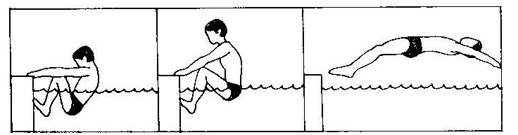

In the diagram sequence of the backstroke start, what is the movement performed at each of the following joints?

* 1. Ankle ***Plantar Flexion***
  2. Knee ***Extension***
  3. Trunk ***Extension***
  4. Shoulder ***Flexion***

**4 marks**

**Question 8**

The graph below illustrates the relative contribution of the three energy systems to exercise of varying duration.

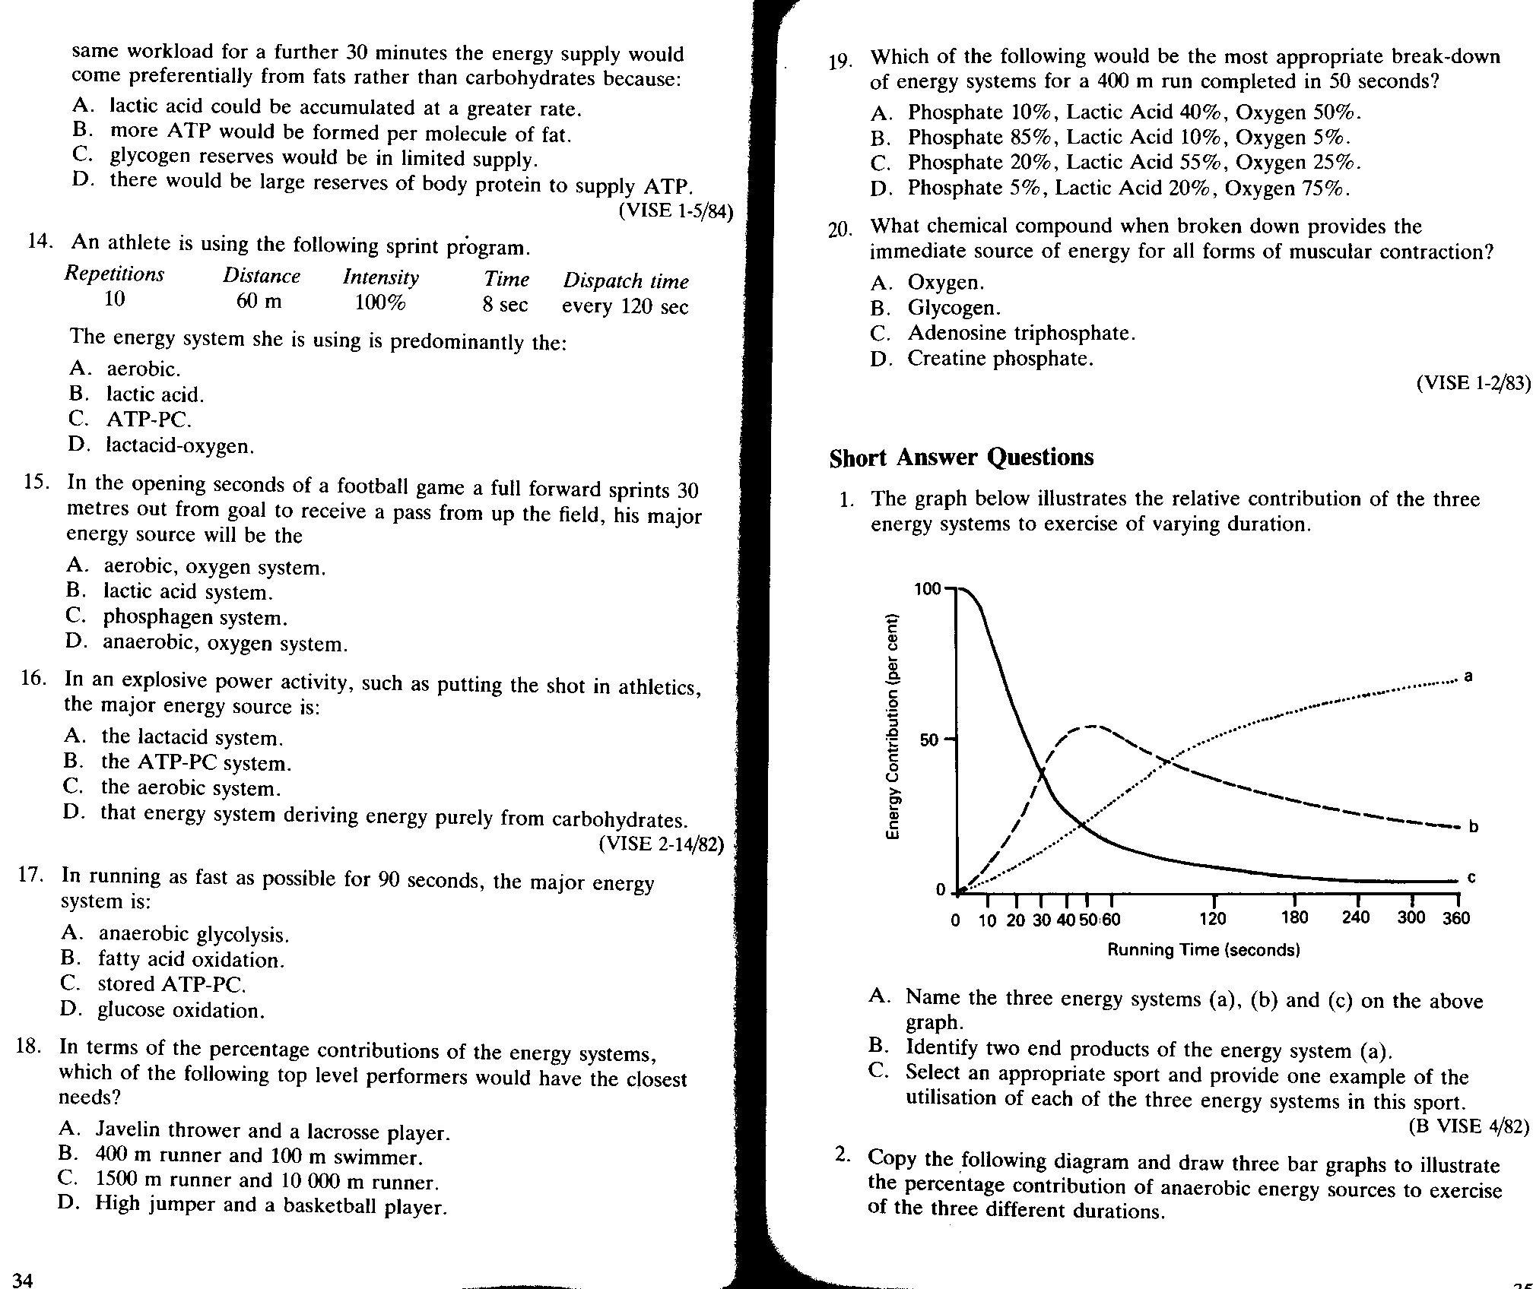

**a.** Name the three energy systems:

(a) ***Aerobic Energy System***

(b) ***Latic Acid Energy System***

(c) ***ATP-CP Energy System***

**3 marks**

**b.** Identify two by-products of energy system (a).

***Any 2 of the following - (1 mark for identifying each factor)***

* ***Carbon Dioxide (CO2)***
* ***Water (H2O)***
* ***Heat***

**2 marks**

**c.** Select an appropriate sport and provide one example of the utilisation of each of the three energy systems in this sport.

***Identifying each of the three energy systems used in the sport. (1 mark each -total 3 marks)***

***Identifying examples within the sport for each of the three energy systems. (1 mark - total 3 marks)***

**6 marks**

**Question 9**

Lisa, a 25 year old, runs 6 km, twice a week. She maintains a heart rate of 130 beats per minute and talks with her running partner all the way. Monthly, she does a time trial but finds her time is always close to 30 minutes.

**a.** Identify what type of training Lisa is doing and name two benefits of this type of training?

**3 marks**

***Indentifies type of training as Continuous Training – 1 mark***

***Any 2 of the following - (1 mark for identifying each benefit)***

* ***Cardiac hypertrophy***
* ***Increases efficiency of the heart – lower resting heart rate***
* ***Decreases body fat***
* ***Lower risk of injury***
* ***Increase in size of slow twitch fibres***
* ***Increase in blood flow to the muscles***
* ***Increased ability to produce ATP aerobically***

**b.** Discuss why Lisa’s times do not improve with respect to

(i) intensity

(ii) progressive overload

(iii) frequency

**6 marks**

***1 mark for identifying each factor (max 2 marks for each principle)***

***Intensity:***

* ***Max HR =220-25 = 195, 130/195 = 67%,***
* ***this intensity doesn’t increase anaerobic threshold***

***Progressive overload:***

* ***Her times don’t improve because she doesn’t overload her body by: increasing the distance run,***
* ***Her times don’t improve because she doesn’t overload her body by: increasing the speed she runs the course.***

***Frequency:***

* ***She only runs 2 times a week 3 times a week is viewed as minimum for aerobic improvement.***
* ***She needs to run 4-5 times a week for improvement to occur.***

**c.** Training programs produce chronic (long-term) training effects. In the table below state one cardiovascular adaptation and one muscular adaptation which will occur as a result of each type of training listed.

**4 marks**

***Any 1 of the following - (1 mark for identifying each benefit)***

|  |  |  |
| --- | --- | --- |
| **Training focused on improving** | **Cardiovascular adaptation** | **Muscular adaptation** |
| Anaerobic capacity | * ***Cardiac hypertrophy (increase in ventricle wall thickness)*** * ***Decrease in blood pressure*** | * ***Increased fast twitch muscle fibre size*** * ***Increased stores of ATP & Creatine Phosphate*** * ***Increased glycolytic capacity*** |
| Aerobic capacity | * ***Decreased resting heart rate*** * ***Decreased blood pressure*** * ***Increase stroke volume*** * ***Increased cardiac output*** * ***Increased blood plasma*** * ***Increased haemoglobin*** * ***Cardiac Hypertrophy (increase in ventricle size)*** | * ***Increased mitochondria density & number*** * ***Increased myoglobin stores*** * ***Increased oxidative enzymes*** * ***Increased capillary density*** * ***Increased use of fat at submaximal exercise*** * ***Increased stores of glycogen*** * ***Increased stores of triglycerides*** * ***Increased arteriovenous oxygen difference*** |

**d.** State the muscle fibre type likely to benefit most from training focused on improving lactic acid tolerance.

**1 mark**

***Fast Twitch (Type 2)***

**Question 10**

Peter Robertson is an elite triathlete and was world champion over the Olympic distance (1.5km swim, 40 km bike and 10km run) in 2001, 2003 and 2005. His average event time is approximately 2 hours.

**a.** Identify a pre, during and post event nutritional strategy that Peter should use and discuss their benefits.

**3 marks**

***Pre race – Carbohydrate loading or Low GI foods (½ mark) /Tapering-increases glycogen stores (½ mark)***

***During the race: - Eat carbohydrates/Hi GI food (½ mark) drink water/sports drink (replenishes glycogen stores lost fluid) (½ mark)***

***Post race: - eat Hi- GI foods to replenish glycogen (½ mark) and protein (aids in recovery) (½ mark)***

**b.** Peter’s endurance training will alter the way his skeletal muscle uses carbohydrates and fats throughout the event compared to a less trained person. State one of the changes in fuel use during the event occurring as a result of endurance training.

**1 mark**

***The body will use fats in preference to glycogen (glycogen sparring)***

**c.** Explain how this change improves performance as the event is nearing the end.

**2 marks**

***Glycogen sparring allows the body to use fats instead of glycogen (1 mark) hence when the intensity towards the end of the event increases the body has more glycogen to use. (1 mark)***

**d.** The following table shows two meals, one is designed as a pre-race meal and the other as a post-race meal.

|  |  |  |
| --- | --- | --- |
| **Meal A** | **Meal B** | |
| Low-fat strawberry milkshake/smoothie | Sports or soft drink | |
| Apple | Honey sandwich | |
| Wholemeal bread roll | Dried fruit | |
| Water | Sweets (lollies) | |
| Baked Beans | | Watermelon |

Identify which of these meals is better eaten 1–2 hours prior to the start of an endurance event. Explain your answer.

**2 mark**

***Meal A (1 mark)***

***Because it has foods with low GI so they will be absorbed into the blood stream slower ie later into the race. (1 mark)***

**e.**  Stretching and flexibility can be improved by training. Briefly explain the **three** different types of flexibility training.

**3 marks**

***Static Stretching – stretching to a position and holding it for 10 secs. (1 mark)***

***Dynamic Stretching – stretching moves the joint through a range of motion. (1 mark)***

***Proprioceptive Neuromuscular Facilitation (PNF) – a partner provides resistance to lengthen the muscle. (1 mark)***

**Question 11**

Athletes of team sports have to fill a variety of positions and are often classified as strikers, mid- fielders or goal-keepers. All of these positions vary slightly in the training that is required, the energy systems utilised and the skills they need to develop.

**a.** Contrast the characteristics of the energy system used predominantly by goalkeepers to the system used by field players.

**4 marks**

***1 mark for identifying energy system & 1 mark for characteristic***

***Goal keeper – ATP-CP short fast burst of movements.***

***Field player – mixture of Aerobic and Latic Acid system as they run around the whole game with some sprints interspersed.***

**b.** Describe which method of training is more beneficial for goal keepers - interval or fartlek.

**3 marks**

***Interval training (1 mark)***

***Because it mainly uses the ATP-PC system. (1 mark)***

***Eg. Running out of goals quickly, diving to save a shot on goal. (1 mark)***

**c.** Choose **two** principles of training and describe their impact upon a goalkeeper’s training.

**2 marks**

***Any 2 of the following - (1 mark for each principle identified and described)***

***Specificty – the goal keeper needs to practice stopping penalties rather than dribbling***

***Progressive overload – the keeper needs to increase the number of repetitions they complete for their interval training, for adaptations to occur to the body.***

***Maintenance – During the competition season the keeper needs to maintain their fitness rather than try to improve as they will overtrain with games being played weekly.***

***Reversibility – if the goal keeper has time off due to injury or illness they will lose fitness.***

***Tedium –changing the sessions will add variety and will keep the goal keeper motivated.***

.

**Question 12**

Refer to the following graph, which shows the heart-rate (bpm) of a 20-year-old runner during two separate running training sessions (**X** and **Y**):

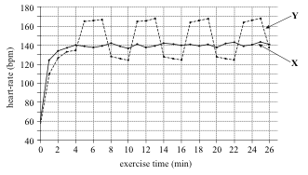

**a.** State the name of the training method used in:

(i) Session **X**. ***Continuous Training***

(ii) Session **Y**. ***Fartlek Training***

**1 mark**

b. Choose a sporting activity and explain how a coach would use the training method for session **Y** in his or her program.

***Identifies sport such as soccer, basketball, racket sport, hockey and so on. (1 mark)***

***Explains shorter and more random intervals will be more appropriate to simulate game play. (1 mark)***

***Gives example eg. jog for 60 seconds, followed by a hard run for 30 seconds, followed by a jog for 30 seconds, followed by all-out sprint for 10 seconds, followed by a walk for 30 seconds. (1 mark)***

**3 marks**

**Question 13**

**a.** Briefly discuss how a high jumper’s recovery in between jumps would be different from a 200m track sprinter’s recovery in between the semi-final and final.

**2 marks**

***High jumper has rest recovery to replenish CP stores (1 mark)***

***Track sprinter has an active recovery to aid in removal of waste products of the lactic acid system (1 mark)***

**b.**  The 200m sprinter completes 8 repetitions of 150m in 18 seconds (high intensity), with a 3 minute recovery between repetitions.

**4 marks (1 + 1 +2)**

**i.** What is the name given to this type of training?

***Interval (1 mark)***

**ii.** What is the predominant energy system being trained while undertaking this session.

***Lactic Acid System or Anaerobic System (1 mark)***

**iii.**  Calculate the work to rest ratio being applied.

***Work : Rest = 18 sec : 180 sec (1 mark)***

***= 1 : 10 (1 mark)***

**c.** Complete the following table by inserting the words “increased”, “decreased” or “unchanged” to indicate the likely adaptations experienced by the sprinter following nine months of training.

**8 marks**

|  |  |
| --- | --- |
| **Oxidative enzymes** | ***Unchanged*** |
| **Glycolytic capacity** | ***Increased*** |
| **Mitochondria density** | ***Unchanged*** |
| **Capillary density** | ***Unchanged*** |
| **Phosphocreatine stores** | ***Increased*** |
| **Triglyceride stores** | ***Unchanged*** |
| **Muscle size** | ***Increased*** |
| **Contraction speed** | ***Increased*** |

**Question 14**

The following table contains a weights program that a student is undertaking to improve muscular power in his arms and legs.

|  |  |  |  |
| --- | --- | --- | --- |
| **Exercise** | **Sets** | **Reps** | **Weight** |
| Lat pull-down | 3 | 5 | 70 kg |
| Seated leg press | 3 | 5 | 98 kg |
| Shoulder press | 6 | 15 | 42 kg |
| Bicep curl | 4 | 10 | 27 kg |
| Leg extension | 4 | 5 | 53 kg |
| Bench press | 6 | 15 | 40 kg |
| Tricep extension | 4 | 5 | 53 kg |
| Leg curl | 3 | 5 | 40 kg |

**a.** To achieve improvements in muscular power, at what % of 1RM should the student be setting their weights for the above program?

**1 marks**

***70-85% of 1RM (1 mark)***

**b.** Identify any activities in the above program that are inappropriate to the stated goal of muscular power improvement. Justify your answer.

**3 marks**

***Shoulder Press (½ mark) – reps & sets too high for improvements in power (½ mark)***

***Bicep Curl (½ mark) – reps & sets too high for improvements in power (½ mark)***

***Bench Press (½ mark) – reps & sets too high for improvements in power (½ mark)***

**c.** Using the seated leg press as an example, indicate how the student would correctly apply the principle of overload to the program.

**2 marks**

***Any 2 of the following - (1 mark)***

***Increase weight, increase speed or add another rep.***

**END OF SECTION B**

**Section C – Extended Answer**

This section has **ONE (1)** question.

Allow approximately 45 minutes for this section [15 marks].

___________________________________________________________________________

**Question 1**

Professional road cycling races, such as the Tour de France, last 21 days during which the cyclists must cover over 3500 kilometres. In some phases of the race, exercise intensity is high, as the cyclists must complete prolonged periods of exercise (e.g. time trials, high mountain ascents) at a high percentage of maximal oxygen up take.

Australia’s Cadel Evans has performed extremely well in the Tour de France over the past couple of years. He cycles 30 000 to 35 000 km per year in training and competition.

**a.** Identify the two major fitness components required by professional cyclists in the Tour de France and outline why they are important.

**4 marks**

**b.** Carbohydrates are required at each part of the race; the lead up to the race, cycling each day and during recovery. Outline the different roles that carbohydrates play at each part of the race.

**3 marks**

**c.** Identify the chronic effects of aerobic training on Cadel’s body and describe how these adaptations would assist his performance.

**8 marks**

***a. Aerobic endurance (cardio-respiratory endurance) (1 mark) – Because the event is so long the aerobic energy system is the dominant system. (1 mark)***

***Muscle endurance (1 mark) – The cycling action is a repetitive movement of the legs so the muscles are continuously contracting. (1 mark)***

***b. Lead up to the race – carbohydrates are vital to ensuring glycogen stores are full. (1 mark)***

***During the race – carbohydrates are used to replenish the gylgcogen lost through aerobic respiration. (1 mark)***

***Post race – carbohydrates are used to replace lost stores of glycogen. (1 mark)***

***c. 1 mark for any of the following with explaination***

|  |  |
| --- | --- |
| **Cardiovascular** | |
| **Heart**  ↑ventricle size  ↑stroke volume (surface area)  ↑cardiac output (Q)  ↓rest and submaximal heart rates  ↓steady state heart rate  ↓recovery heart rates | **Heart**  Increased ventricle size contributes to increased cardiac output, which allows more blood, oxygen and fuels to be pumped to working muscles and more efficient/speedier removal of by-products.  Heart able to reach steady state quicker and hence limit oxygen deficit and reliance on anaerobic energy systems. Less ‘work’ required up to maximal levels and more oxygen available to working muscles. Quicker return to resting levels and smaller/faster oxygen debt. |
| **Blood vessels**  ↑capillary density to heart muscle  ↑blood flow (20%) away from organs to working muscles  ↑capillary density at muscles, mainly slow twitch  ↑HDL (more high density lipoproteins)  ↓LDL (less bad cholesterol) | **Blood vessels**  More blood pumped to actual heart and working muscles, lowering likelihood of anaerobic by-products causing fatigue.  Increased HDL acts to remove plaque from arteries and lower cholesterol levels. This decreases amount of resistance in blood vessels. |
| **Blood**  ↑blood volume  ↑plasma levels  ↑red blood cell count  ↑haemoglobin  ↑myoglobin  ↑OBLA  ↓blood pressure (rest and submaximal) | **Blood**  Greater blood volumes increase amount of oxygen transportation to and by-product removal from working muscles. Increased plasma slows fatigue caused by dehydration and elevated body temperature.  Increased myoglobin increases rate of oxygen transfer from cell membranes to mitochondria where aerobic energy can be produced.  Decreased blood pressure has a cardio protective effect |

|  |  |
| --- | --- |
| **Respiratory** | |
| ↑lung/vital capacity  ↑aerobic capacity  ↑tidal volume  ↑alveolar – capillary surface area  ↑pulmonary diffusion  ↑ventilation (max intensity)  ↓oxygen cost to ventilatory muscles (intercostals and diaphragm)  ↓ventilation (rest and submaximal) | Increased lung capacity allows for more O2 to be taken in to the body to then be transported to muscles.  Increased aerobic capacity improves restoration of CP as well as allowing body to use aerobic system for greater part of the activity.  Greater surface area of alveoli combined with capillary density makes for a larger diffusion site allowing greater amounts of gases to be exchanged at the lungs.  Decreased oxygen cost means more oxygen available to be sent to working muscles. |
| **Muscular** | |
| ↑aVO2 diff.  ↑capillary supply/density  ↑myoglobin stores  ↑mitochondria (size, number and surface area)  ↑oxidative enzymes  ↑glycogen stores  ↑triglyceride stores  ↑fibre size  ↑glycogen sparing  ↑glycogen synthase | Improved aVO2 diff. means more oxygen can be extracted by working muscles and increased surrounding capillaries will further enhance this supply as well as facilitate removal of by-products.  Increased mitochondria will allow for greater aerobic ATP release and oxidative enzymes will contribute to this as well.  Greater glycogen and triglyceride stores will enable muscles to work for longer. Muscles ‘trained’ to first use available triglycerides and then use glycogen later in the performance and hence glycogen spare. This allows for higher intensities later in the performance. Glycogen synthase assists storing of glycogen from glucose. |

**END OF PAPER**